📘 PROJECT REPORT
Inventory Management System (Python)

1. Introduction
Inventory Management System is a software application developed using Python programming language.
It helps an organization to manage products, staff, and sales efficiently.
The system provides two types of users:
- Admin
- Staff
Admin has full control over the system, while staff has limited access.

2. Objectives
- To maintain product stock
- To reduce manual record keeping
- To provide secure login system
- To manage staff details
- To generate sales reports
- To improve accuracy and efficiency

3. Scope of the Project
This project is useful for:
- Small shops
- Supermarkets
- Retail stores
- Inventory-based businesses

4. Software Requirements
Component | Description
Language | Python 3.12
IDE | VS Code
OS | Windows
Modules | prettytable, datetime
Storage | Text files

5. Hardware Requirements
- Processor: Intel i3 or above
- RAM: 4 GB or above
- Hard Disk: 20 GB
- Keyboard & Monitor

6. Modules Description
1️⃣ Admin Module
- Admin login
- Add new staff
- View staff
- Add product
- Update product
- Delete product
- View inventory
- View sales report
2️⃣ Staff Module
- Staff login
- View inventory
- Sell products
- View sales report
3️⃣ Inventory Module
- Add product
- Search product
- Update product
- Delete product
- Store data in file
4️⃣ Sales Module
- Record sales
- View sales report
- Calculate total revenue

7. Features
- Role-based login system
- File handling
- Data persistence
- User-friendly menu
- Secure authentication
- Real-time stock update

8. Advantages
- Easy to use
- Saves time
- Reduces paperwork
- Low cost
- Accurate calculations

9. Limitations
- Console-based interface
- No encryption
- Single-user system
- Uses text files instead of database

10. Future Enhancements
- GUI using Tkinter
- Database using MySQL
- Barcode scanning
- Online system
- Role-based permissions

11. Conclusion
The Inventory Management System successfully manages products, staff, and sales.
It helps businesses maintain proper stock records and improves efficiency.

🔁 FLOWCHART
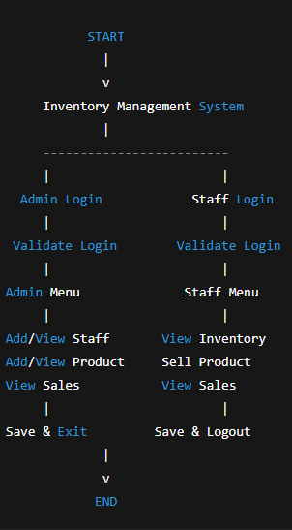
🔹 Overall Flowchart

🧩 UML DIAGRAMS

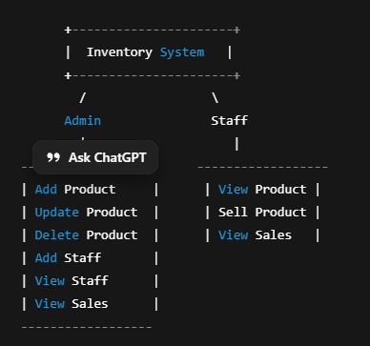
1️⃣ USE CASE DIAGRAM

2️⃣ SEQUENCE DIAGRAM (Admin Login)
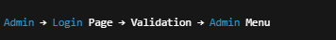

3️⃣ ACTIVITY DIAGRAM
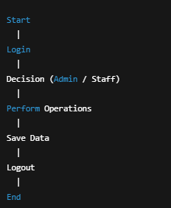

4️⃣ CLASS DIAGRAM
